Supplementary materials

Species | Functional type | Site | Distribution
Cassiope tetragona | Evergreen shrub | Alexandra fiord | Erect-shrub tundra S1,  Graminoid, prostrate dwarf-shrub, forb, moss tundra G2, Prostrate / hemi-prostrate dwarf-shrub, lichen tundra P2
Dryas integrifolia | Evergreen shrub | Alexandra fiord | Graminoid, prostrate dwarf-shrub, forb, moss tundra G2, Prostrate dwarf-shrub, herb, lichen tundra P1,  Prostrate / hemi-prostrate dwarf-shrub, lichen tundra P2
Oxyria digyna | Forb | Alexandra fiord | Graminoid, forb, cryptogam tundra G1,  Graminoid, prostrate dwarf-shrub, forb, moss tundra G2, Prostrate / hemi-prostrate dwarf-shrub, lichen tundra P2
Papaver radicatum | Forb | Alexandra fiord | Cryptogam, herb barren B1, Graminoid, forb, cryptogam tundra G1, Graminoid, prostrate dwarf-shrub, forb, moss tundra G2
Luzula confusa | Graminoid | Alexandra fiord | Cryptogam, herb barren B1,  Prostrate dwarf-shrub, herb, lichen tundra P1,  Prostrate / hemi-prostrate dwarf-shrub, lichen tundra P2
Eriophorum vaginatum | Graminoid | Daring Lake | Tussock- sedge, dwarf-shrub, moss tundra G4,  Erect-shrub tundra S1
Rhododendron tomentosum  ssp. decumbens | Evergreen shrub | Daring Lake | Cryptogam, barren, dwarf-shrub complex B2b,  Prostrate/hemi-prostrate dwarf-shrub, lichen tundra P2,  Low-shrub, moss tundra S2, Sedge, moss, dwarf-shrub wetland complex W2
Salix pulchra/planifolia | Deciduous shrub | Daring Lake | Sedge, moss, dwarf-shrub wetland complex W2, Tussock- sedge, dwarf-shrub, moss tundra G4
Saxifraga tricuspidata | Forb | Daring Lake | B4 Carbonate mountain complex elevation belt d & e
Vaccinium  vitis-idea | Evergreen shrub | Daring Lake | Cryptogam, barren, dwarf-shrub complex B2b,  Tussock- sedge, dwarf-shrub, moss tundra G4,  Erect-shrub tundra S1,  Low-shrub, moss tundra S2
Betula glandulosa | Deciduous shrub | Daring Lake | Cryptogam, barren, dwarf-shrub complex B2b,  Sedge, moss, low-shrub wetland complex W3,  Low-shrub, moss tundra S2
Oxytropis nigrescens | Forb | Daring Lake | B4 Carbonate mountain complex elevation belt d & e
Table S1. Names, plant functional types, study site location and circum- polar/boreal distribution information for the 12 tundra species included in this synthesis. Distribution zones are from the Circumpolar Arctic Vegetation Map (CAVM, Table S1) (Raynolds et al. 2019).

a)

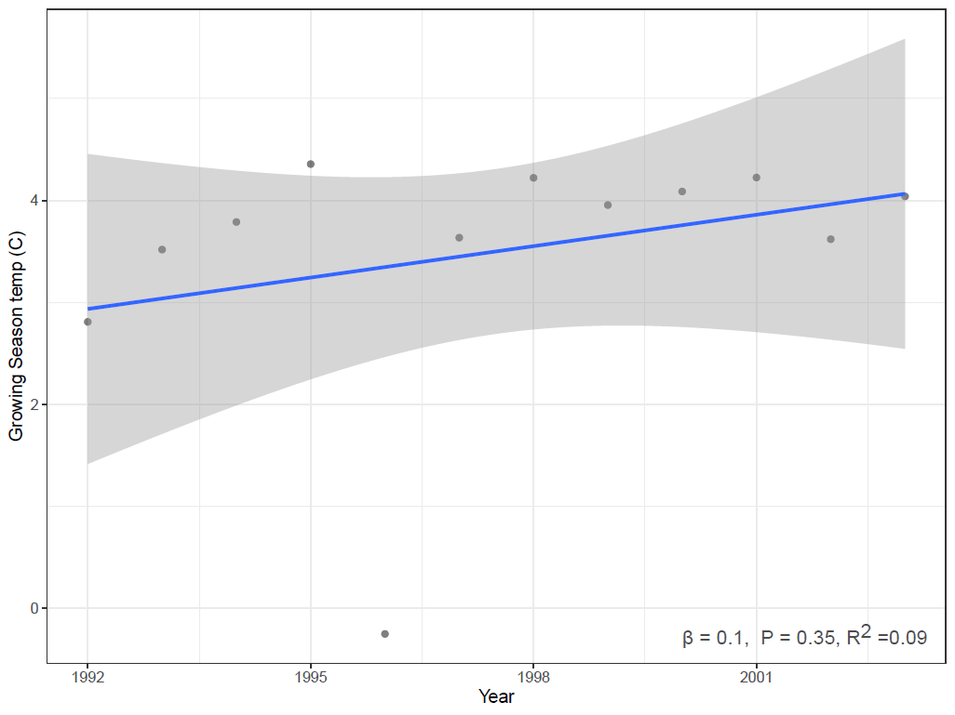
b)

Fig S1. a) Observed snow free day of year (DOY) for each species at Daring Lake from 2001-2022. Simple linear regression shows a negative pattern over the time period of this study, with snowmelt advancing by approximately 6 days overall. b) Average growing season (June - Aug) air temperature (degrees C) at Alexandra Fiord plotted by year from 1992-2003. Simple linear regression shows a slightly positive but non-significant warming pattern over the time period of this study. Regression lines are plotted by the function ‘geom_smooth’ in the R package ggplot2 (Wickham 2009).

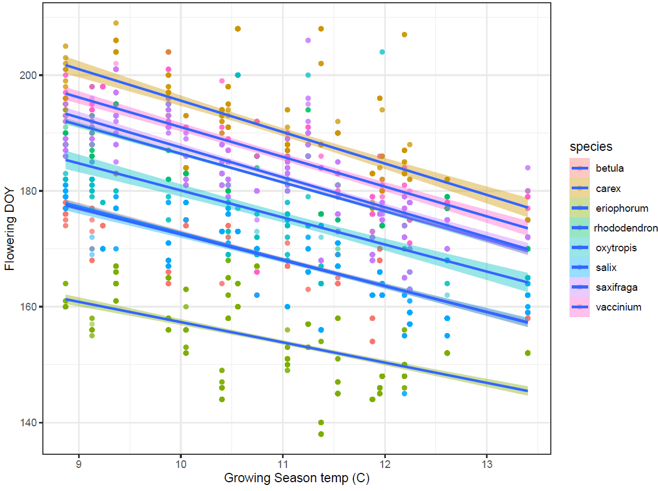

Fig S2. Species level flowering phenology (Julian day of year of mature flower –DOY) by temperature: a) Average summer growing season (June-August) air temperature (degrees C) and b) experimental warming treatment (open-top chambers) vs. ambient (control). Note that species flower earlier in warmer temperatures at both sites. Simple linear regressions are plotted by the function ‘geom_smooth’ in the R package ggplot2 (Wickham 2009).

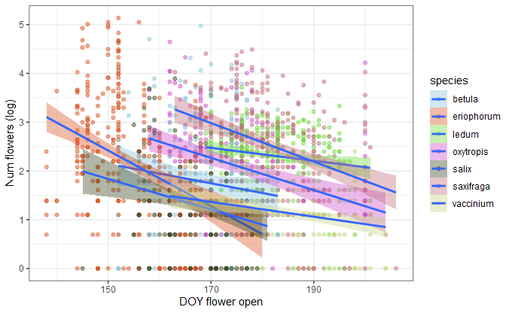
a)

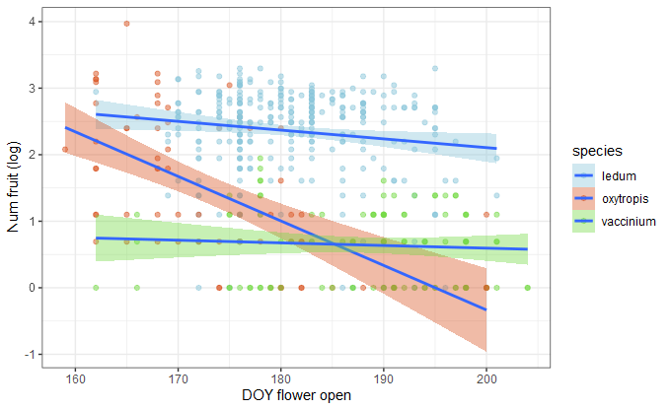
b)

Fig S3. Species level flowering phenology (Julian day of year of mature flower –DOY) by reproductive fitness (number of flowers, number of fruits). Daring lake plots (a, b- above) are colored by species and Alexandra Fiord plots (c,d- below) are separated by species and colored by experimental warming treatment (open-top chambers) vs. ambient (control). Simple linear regressions are plotted by the function ‘geom_smooth’ in the R package ggplot2 (Wickham 2009).

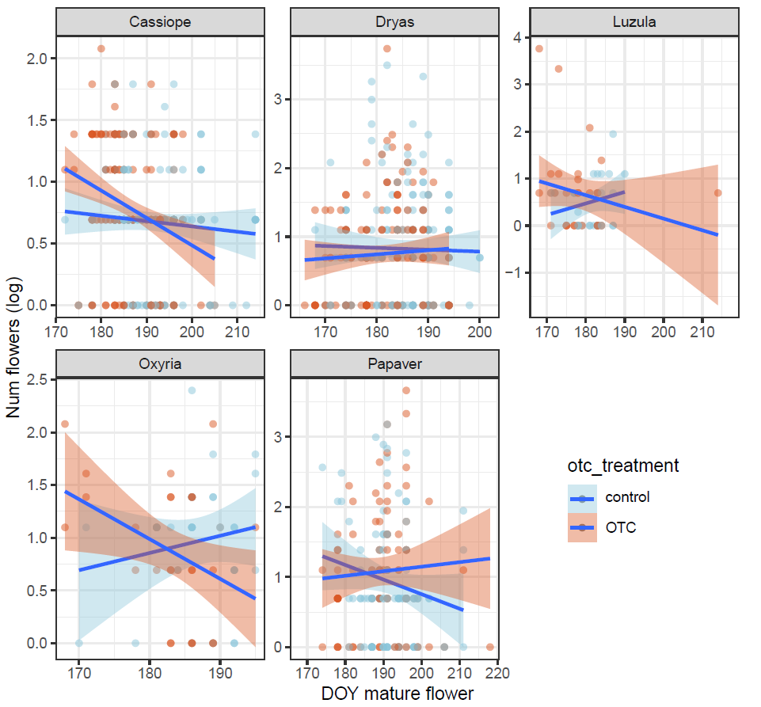

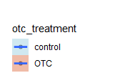

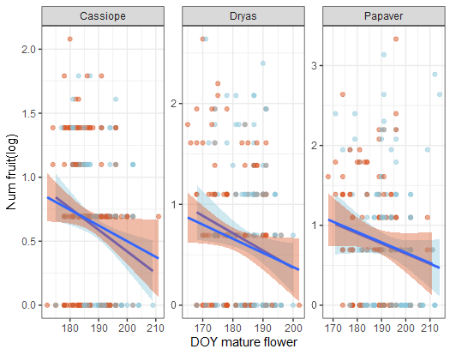

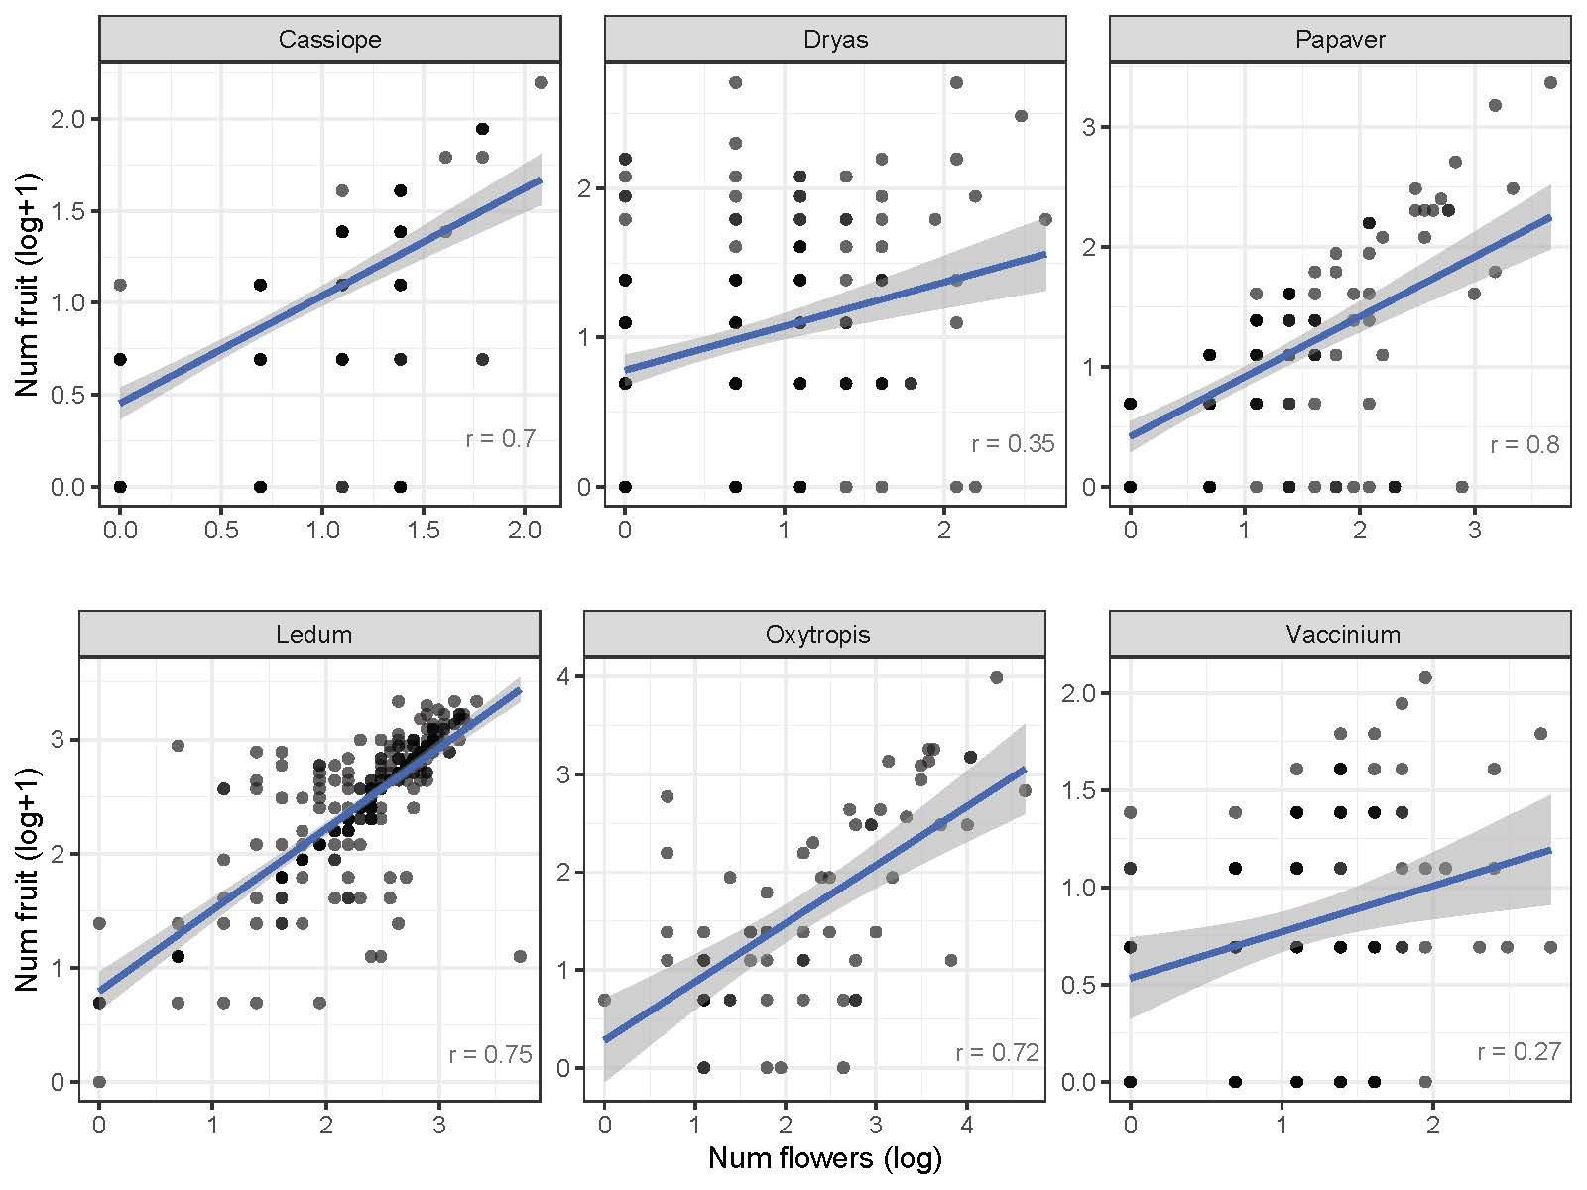

Fig S4. Relationships between flower number and fruit number of individual plants across species. Pearson’s correlation values (r) are shown in the bottom right and simple linear regressions are plotted on raw data with the function ‘geom_smooth’ in the R package ggplot2 (Wickham 2009). Species in the top row are from Alexandra Fiord and in the bottom row are from Daring Lake.

Appendix 1- Model performance
Flower number- Daring Lake

Posterior predictive checks
DOY flower
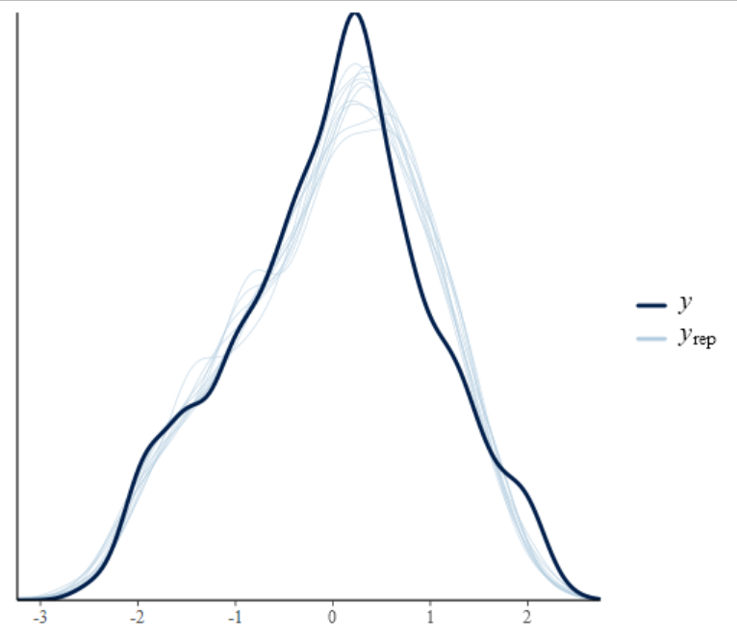

log(flower count)
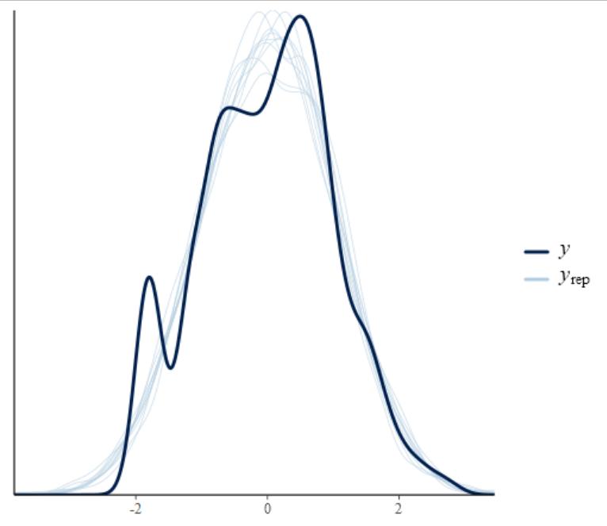

Leave one out (LOO) cross validation
Computed from 15000 by 1584 log-likelihood matrix

Estimate SE
elpd_loo -2553.7 57.6
p_loo 149.4 5.3
looic 5107.4 115.3
------
Monte Carlo SE of elpd_loo is 0.1.

Pareto k diagnostic values:
Count Pct. Min. n_eff
(-Inf, 0.5] (good) 1583 99.9% 2820
(0.5, 0.7] (ok) 1 0.1% 811
(0.7, 1] (bad) 0 0.0% <NA>
(1, Inf) (very bad) 0 0.0% <NA>

All Pareto k estimates are ok (k < 0.7)

Fruit number- Daring Lake

Posterior predictive checks
DOY flower
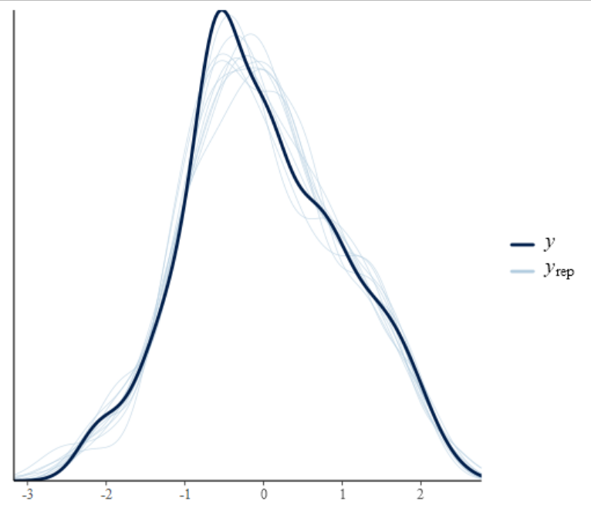
log(fruit count)
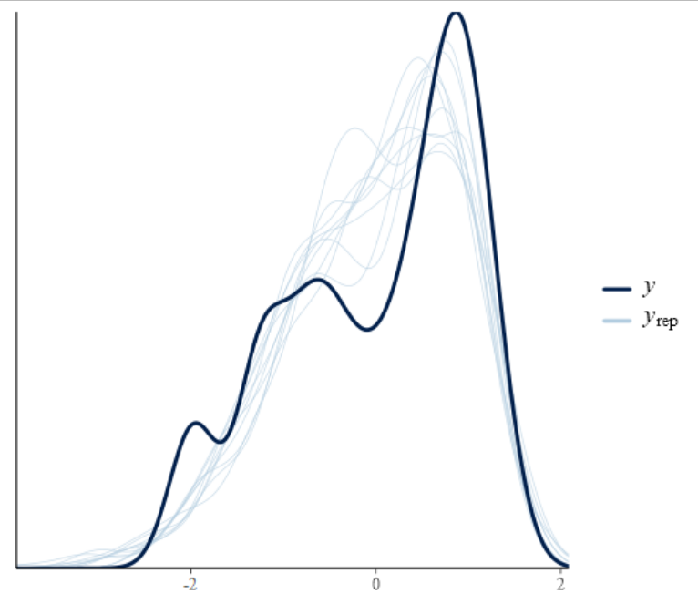

Leave one out (LOO) cross validation
Computed from 15000 by 510 log-likelihood matrix

Estimate SE
elpd_loo -682.4 42.2
p_loo 84.0 8.3
looic 1364.9 84.5
------
Monte Carlo SE of elpd_loo is NA.

Pareto k diagnostic values:
Count Pct. Min. n_eff
(-Inf, 0.5] (good) 475 93.1% 1372
(0.5, 0.7] (ok) 25 4.9% 692
(0.7, 1] (bad) 9 1.8% 30
(1, Inf) (very bad) 1 0.2% 51

LOO cross validation refit (i.e. reloo)
Computed from 15000 by 510 log-likelihood matrix

Estimate SE
elpd_loo -684.0 42.3
p_loo 85.5 8.8
looic 1368.0 84.6
------
Monte Carlo SE of elpd_loo is 0.4.

Pareto k diagnostic values:
Count Pct. Min. n_eff
(-Inf, 0.5] (good) 481 94.3% 24
(0.5, 0.7] (ok) 29 5.7% 291
(0.7, 1] (bad) 0 0.0% <NA>
(1, Inf) (very bad) 0 0.0% <NA>

All Pareto k estimates are ok (k < 0.7).

Flower number- Alexandra Fiord
Posterior predictive checks
DOY flower
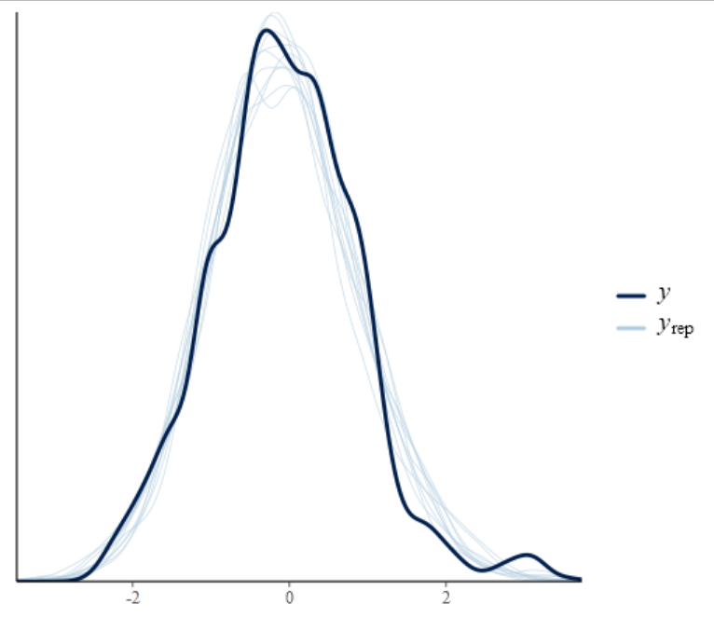

Flower count
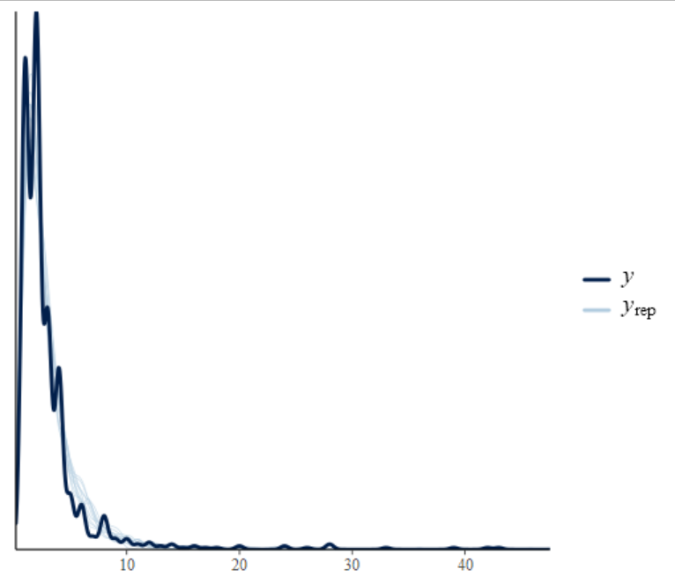

Leave one out (LOO) cross validation
Computed from 15000 by 930 log-likelihood matrix

Estimate SE
elpd_loo -2540.7 51.0
p_loo 89.4 4.7
looic 5081.4 102.1
------
Monte Carlo SE of elpd_loo is 0.1.

Pareto k diagnostic values:
Count Pct. Min. n_eff
(-Inf, 0.5] (good) 928 99.8% 2518
(0.5, 0.7] (ok) 2 0.2% 440
(0.7, 1] (bad) 0 0.0% <NA>
(1, Inf) (very bad) 0 0.0% <NA>

All Pareto k estimates are ok (k < 0.7).

Fruit number- Alexandra Fiord
Posterior predictive checks

DOY flower
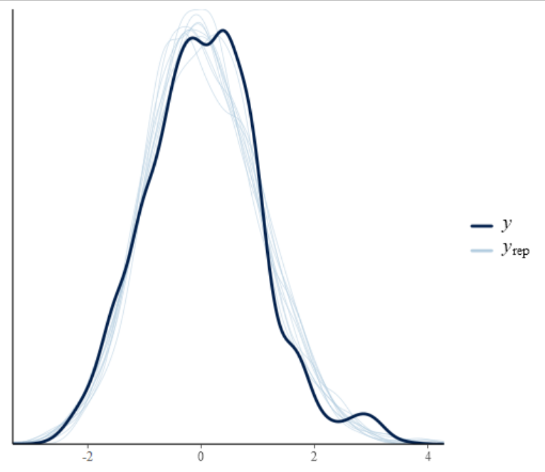
Fruit count
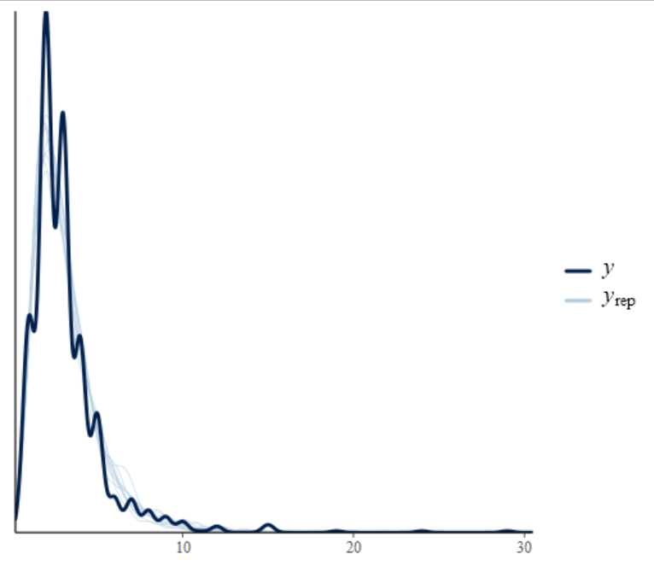

Leave one out (LOO) cross validation

Computed from 15000 by 1013 log-likelihood matrix

Estimate SE
elpd_loo -2728.8 42.6
p_loo 74.2 3.6
looic 5457.7 85.2
------
Monte Carlo SE of elpd_loo is 0.1.

Pareto k diagnostic values:
Count Pct. Min. n_eff
(-Inf, 0.5] (good) 1011 99.8% 4105
(0.5, 0.7] (ok) 2 0.2% 2294
(0.7, 1] (bad) 0 0.0% <NA>
(1, Inf) (very bad) 0 0.0% <NA>

All Pareto k estimates are ok (k < 0.7).

References
Hill, G. B., and G. H. R. Henry. 2011. Responses of High Arctic wet sedge tundra to climate warming since 1980. Global Change Biology 17:276–287.

Raynolds, M. K., D. A. Walker, A. Balser, C. Bay, M. Campbell, M. M. Cherosov, F. J. A. Daniëls, P. B. Eidesen, K. A. Ermokhina, G. V. Frost, B. Jedrzejek, M. T. Jorgenson, B. E. Kennedy, S. S. Kholod, I. A. Lavrinenko, O. V. Lavrinenko, B. Magnússon, N. V. Matveyeva, S. Metúsalemsson, L. Nilsen, I. Olthof, I. N. Pospelov, E. B. Pospelova, D. Pouliot, V. Razzhivin, G. Schaepman-Strub, J. Šibík, M. Yu. Telyatnikov, and E. Troeva. 2019. A raster version of the Circumpolar Arctic Vegetation Map (CAVM). Remote Sensing of Environment 232:111297.
Wickham, H. 2009. Elegant Graphics for Data Analysis. Springer Publishing Company, Incorporated.

